PERIA  SCHOOL  CHARTER  2016 | 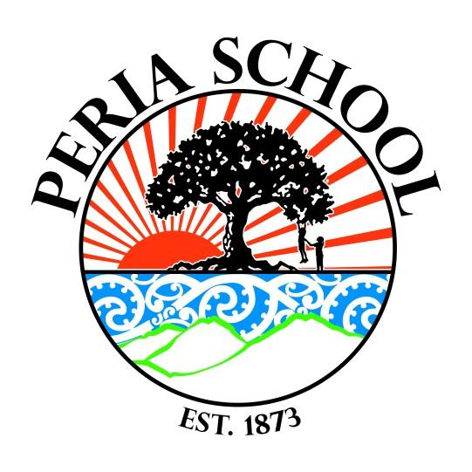
 | For a brighter future

CONTENTS

SCHOOL VISION AND MISSION STATEMENT
Core values
Description
NATIONAL PRIORITIES
National and Local Priorities
Cultural diversity and Community consultation

STRATEGIC PLAN

Strategic Plan overview 2016 -2018
Annual Plans for Strategic Goals
Student Achievement Targets

Mission Statement

We will support and inspire our children to develop holistically and achieve academically to their highest potential using a curriculum that recognises the diversity of their interests and talents, that develops their creativity and ability to lead the way in sustainable practices and that engages each child and the school community with their learning.

Vision

Each child working in harmony to learn, create and grow.

Our Core Values

I care - kaitiakitanga - I care and have respect for myself, for others, for our school, our community and for our global environment

I have courage - whakamanawanui - I have courage to try new things, to strive for excellence, to stand up for what I believe in, to think for myself and have confidence in myself.

We work together - Manaakitanga / Ako - We can work as a team, communicate clearly with each other, use empathy and compassion to support each other and learn together

Whakamohio ~ Description

Peria School is a Full Primary Yr 1 - 8.

Peria School is located in an area of significant historical importance to both local iwi and early European settlers. Long ago the area from Taipa through to Oruru and further up the valley (later called Peria), was densely populated by people from the Ngati Kahu tribe. When referring to the people of the district in Maori oratory it is quoted, “Maungataniwha is the mountain, Ngati kahu is the tribe, Mamaru is the canoe, Taipa is the place where they landed and Oruru is the home of the people”. The proximity to food resources of the bush, river and sea made it an ideal place to live and horticulture flourished in the rich valley floor soil.

In 1866 land was given for a church, marae and school from Rangatira Papahia and his tribe. Lessons were given to children in the church until the school was opened opposite the church in 1873. The marae built nearby to the school took its name Kauhanga from the never conquered Kauhanga Pah at Peria. Peria School was the first public Māori school in the north, students were instructed in a wide variety of skills including the finer points of grafting and budding fruit trees and how to attract and keep native bees.

From 1860-1880 Peria was a lively gum digging and timber felling area. Local land known as Kaurinui was said to contain the best area of Kauri trees in the north, these were felled, pulled out by draft horses and bullock teams and floated down the Oruru river to the coast.

Over the years the school has had grown and had many improvements to its facilities. The local community has seen farming take over as the main land use and then a lot of farm land being split up into lifestyle blocks. Farming, forestry, horticulture, sustainable living and bee keeping remain the main land uses and Peria also supports an active community of creative artists and musicians. The facilities at school have been developed over the years with the help of the community to provide students with an engaging, creative, productive and sustainable environment. The current Peria School utilises three classrooms, an Art room, Library and Hall and shares the site with a Playcentre for preschoolers.

Recognising our Cultural Diversity and Taha Māori - the unique position of Māori

Peria School, as appropriate to its community, will develop procedures and practices that reflect New Zealand’s cultural diversity and the unique position of Māori culture. An open inclusive culture operates in the school. People are valued and respected. The unique perspectives of our diverse Peria community will be valued and integrated into our curriculum.
The Board strongly encourages initiatives supporting the unique position of Māori culture within New Zealand and within our local area. The establishment of cultural identity is important in this process, provision will be made for pupils to learn and understand the Māori language and its culture and heritage. The curriculum will include turangawaewae, history, whakapapa, and the geographical features of Peria. This will promote knowledge of the Tikanga of Peria. Marae experiences and kapa haka will be important parts of the curriculum and will be included whenever possible.

NATIONAL PRIORITIES
The school will incorporate national and local priorities into its strategic plan.
The national education goals are currently determined to be:

NEG 1
The highest standards of achievement, through programmes which enable all students to realise their full potential as individuals, and to develop the values needed to become full members of New Zealand's society.

NEG 2
Equality of educational opportunity for all New Zealanders, by identifying and removing barriers to achievement.

NEG 3
Development of the knowledge, understanding and skills needed by New Zealanders to compete successfully in the modern, ever-changing world.

NEG 4
A sound foundation in the early years for future learning and achievement through programmes which include support for parents in their vital role as their children's first teachers.

NEG 5
A broad education through a balanced curriculum covering essential learning areas. Priority should be given to the development of high levels of competence (knowledge and skills) in literacy and numeracy, science and technology and physical activity.

NEG 6
Excellence achieved through the establishment of clear learning objectives, monitoring student performance against those objectives, and programmes to meet individual need.

NEG 7
Success in their learning for those with special needs by ensuring that they are identified and receive appropriate support.

NEG 8
Access for students to a nationally and internationally recognised qualifications system to encourage a high level of participation in post-school education in New Zealand.

NEG 9
Increased participation and success by Māori through the advancement of Māori education initiatives, including education in Te Reo Māori, consistent with the principles of the Treaty of Waitangi.

NEG 10
Respect for the diverse ethnic and cultural heritage of New Zealand people, with acknowledgment of the unique place of Māori, and New Zealand's role in the Pacific and as a member of the international community of nations.

Local priorities will be identified through:

- The school’s programme of self-review;
- Analysis of the school’s assessment data
- Community consultation

In meeting the national and local priorities, the school undertakes to work within the National Administration Guidelines framework

Community Partnership and Consultation Procedure

Communication by fortnightly school newsletters, newspaper briefs and other media.

At the end of the financial year an annual report, consistent with the Government Annual Reporting Guidelines and a financial statement, duly audited, shall be tabled and made available for public scrutiny at the school’s office or at any other appropriate local places.

Seek community consultation regarding new policy development.

The monthly meeting of the Board of Trustees shall be open to the public and parents shall be encouraged to attend. Dates of meetings will be published in school newsletters.

A copy of the goals which have been prepared by the Board of Trustees prior to each financial year shall be tabled, copies being available at the school’s office and other appropriate places.

The Board of Trustees shall consult with the community in general as well as the Māori community concerning the School Charter. Community feedback and input will be used in reviewing the school’s vision, mission, values, and strategic goals.

Parents will be encouraged to participate in all school activities.

An annual plan will be tabled at the December meeting of the Board of trustees. Copies of this plan will be available to the community via the school office.

GROUP | DETAILS | DATES
Whole school community | Review of our goals and Strategic Plan  Venue: Peria School | Terms 1 & 4
Wider local Maori Community | Aspirations for their children plus a review  of our goals and Strategic Plan  Venue: Kauhanga Marae | Term 2

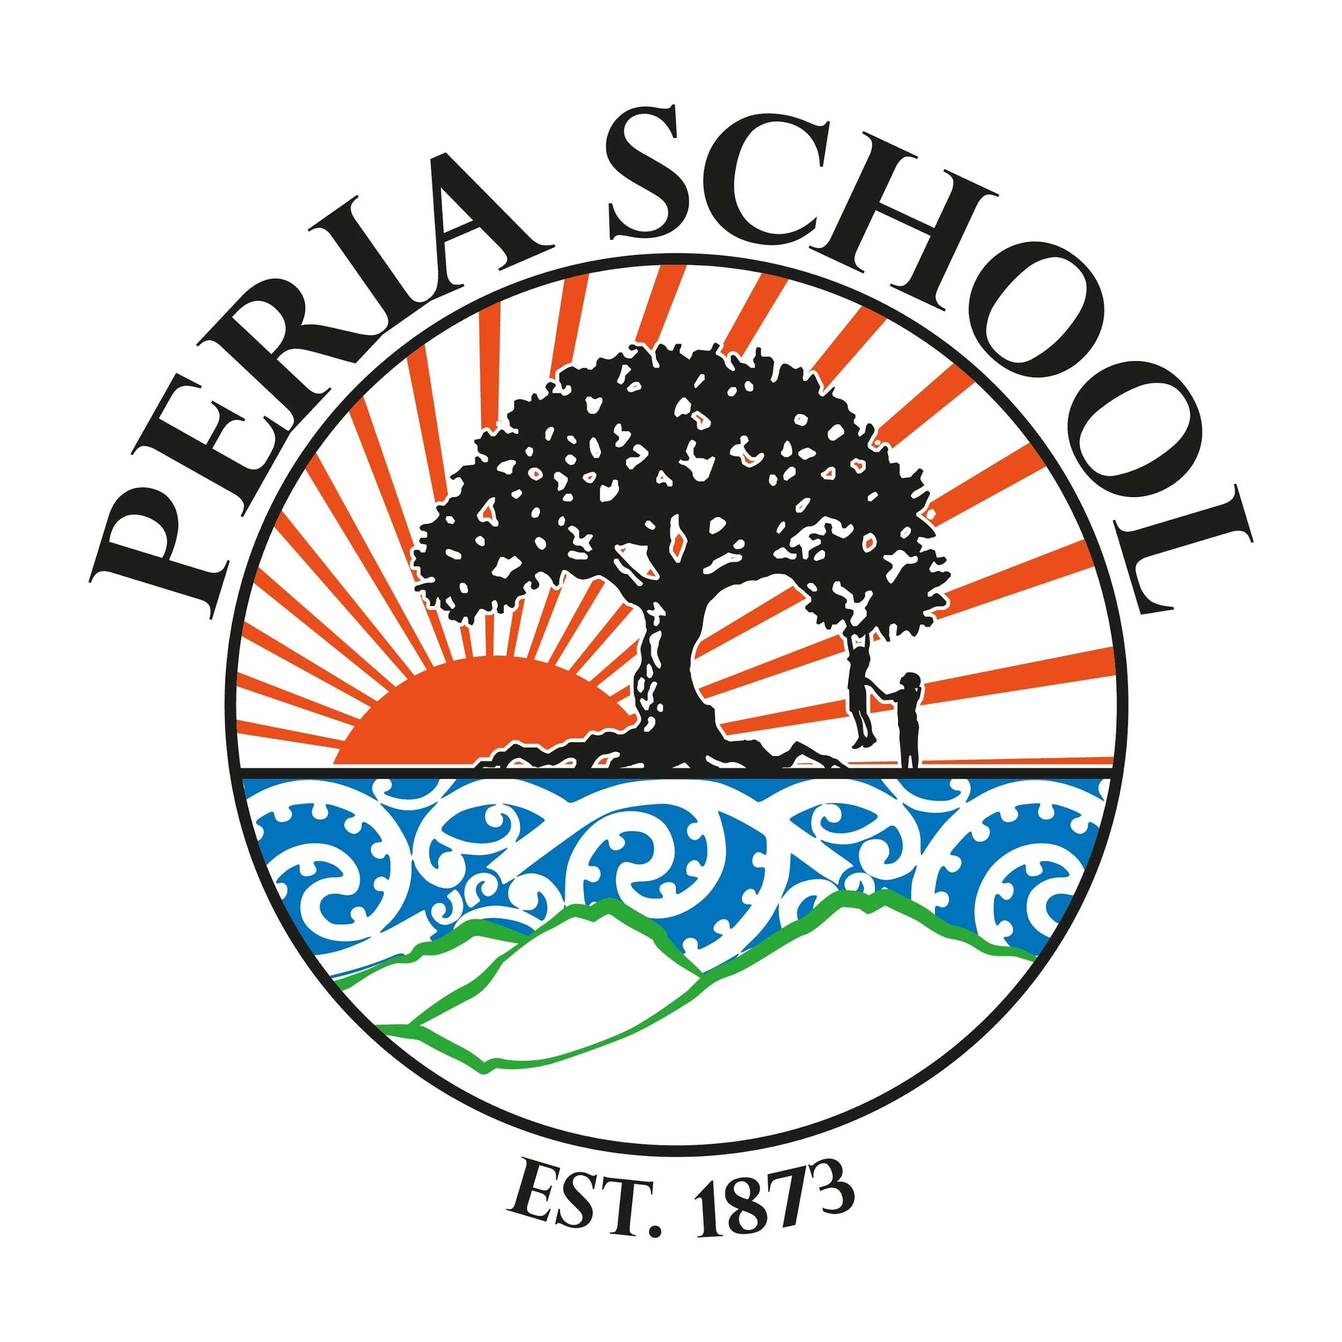
Long Term Strategic Plan

Mission Statement
We will support and inspire our children to develop holistically and achieve academically to their highest potential using a curriculum that recognises the diversity of their interests and talents, that develops their creativity and ability to lead the way in sustainable practices and that engages each child and the school community with their learning.
Vision: Each child working in harmony to learn, create and grow.

Domains of organisational influence on student achievement  Selected indicator goals | Core Strategies (practices) and strategic goals to successfully impact on student achievement  2016 | 2017 | 2018
Responsive curriculum, effective teaching and opportunity to learn  Students learn, achieve and progress in the breadth and depth of The New Zealand Curriculum  Students have effective, sufficient and equitable opportunities to learn  Effective and culturally responsive pedagogy supports and promotes student learning  Effective assessment for learning develops students’ assessment and learning to learn capabilities | Strategic Goal: ACHIEVE  We will provide and monitor a quality learning programme as outlined in the NZC in order to enable all students to progress and achieve to their full potential.  Strategic Goal: INTEREST  We will use participation in; art, drama, music, speaking, science, inquiry and technology to enhance students’ creativity, their holistic development and their achievement of the fundamental skills of reading, writing and mathematics. | Strategic Goal: ACHIEVE  We will provide and monitor a quality learning programme as outlined in the NZC in order to enable all students to progress and achieve to their full potential.  Strategic Goal: INTEREST  We will use participation in; art, drama, music, speaking, science, inquiry and technology to enhance students’ creativity, their holistic development and their achievement of the fundamental skills of reading, writing and mathematics. | Strategic Goal: ACHIEVE  We will provide and monitor a quality learning programme as outlined in the NZC in order to enable all students to progress and achieve to their full potential.  Strategic Goal: INTEREST  We will use participation in; art, drama, music, speaking, science, inquiry and technology to enhance students’ creativity, their holistic development and their achievement of the fundamental skills of reading, writing and mathematics.
Educationally powerful connections and relationships  Learning centred relationships effectively engage and involve the school community  Communication supports and strengthens reciprocal, learning centred relationships.  Student learning at home is actively promoted through the provision of relevant learning opportunities, resources and support  Community collaboration and partnerships extend and enrich opportunities for students to become confident, connected, actively involved, lifelong learners. | STRATEGIC GOAL: CONNECT  We will utilise real world learning opportunities both out in the community and within the school environment. We will be the school of choice in our area and we will foster community, family and whānau involvement with the school and its students. | STRATEGIC GOAL: CONNECT  We will utilise real world learning opportunities both out in the community and within the school environment. We will be the school of choice in our area and we will foster community, family and whānau involvement with the school and its students. | STRATEGIC GOAL: CONNECT  We will utilise real world learning opportunities both out in the community and within the school environment. We will be the school of choice in our area and we will foster community, family and whānau involvement with the school and its students.
Stewardship  The board of trustees scrutinises the work of the school in achieving valued student outcomes  The board of trustees effectively meets statutory requirements  The board of trustees evaluates the effectiveness of board performance in its governance and stewardship role | - Student Achievement Reporting schedule is finalised and carried out in a timely manner throughout the year, this leads to rigorous, honest monitoring of progress and evaluation of effectiveness in improving student outcomes.  - Resourcing is used strategically  to support improvement.  - The board of trustees effectively manages the performance of the principal, linking the school's strategic direction, goals, priorities and targets; appraisal goals; and appropriate professional learning and development opportunities.  - Policy framework is current, coherent and fit for purpose. Monitoring and review schedule is completed each year as per triennial review schedule.  - The school complies with curriculum, human resource, health and safety, financial, property and administration requirements.  - Review and reflect on board performance and effectiveness in terms of the school vision, values, strategic direction, goals and priorities  - Ensure ongoing improvement in the effectiveness and efficiency of governance and stewardship, through induction and ongoing training, the distribution of tasks and succession planning. | - Student Achievement Reporting schedule is finalised and carried out in a timely manner throughout the year, this leads to rigorous, honest monitoring of progress and evaluation of effectiveness in improving student outcomes.  - Resourcing is used strategically  to support improvement.  - The board of trustees effectively manages the performance of the principal, linking the school's strategic direction, goals, priorities and targets; appraisal goals; and appropriate professional learning and development opportunities.  - Policy framework is current, coherent and fit for purpose. Monitoring and review schedule is completed each year as per triennial review schedule.  - The school complies with curriculum, human resource, health and safety, financial, property and administration requirements.  - Review and reflect on board performance and effectiveness in terms of the school vision, values, strategic direction, goals and priorities  - Ensure ongoing improvement in the effectiveness and efficiency of governance and stewardship, through induction and ongoing training, the distribution of tasks and succession planning. | - Student Achievement Reporting schedule is finalised and carried out in a timely manner throughout the year, this leads to rigorous, honest monitoring of progress and evaluation of effectiveness in improving student outcomes.  - Resourcing is used strategically  to support improvement.  - The board of trustees effectively manages the performance of the principal, linking the school's strategic direction, goals, priorities and targets; appraisal goals; and appropriate professional learning and development opportunities.  - Policy framework is current, coherent and fit for purpose. Monitoring and review schedule is completed each year as per triennial review schedule.  - The school complies with curriculum, human resource, health and safety, financial, property and administration requirements.  - Review and reflect on board performance and effectiveness in terms of the school vision, values, strategic direction, goals and priorities  - Ensure ongoing improvement in the effectiveness and efficiency of governance and stewardship, through induction and ongoing training, the distribution of tasks and succession planning.
Leadership of conditions for equity and excellence  Leadership establishes and ensures an orderly and supportive environment conducive to student learning and wellbeing  Leadership collaboratively develops and enacts the school’s vision, values, goals and priorities for equity and excellence  Leadership ensures effective planning, coordination and evaluation of the school’s curriculum and teaching  Leadership promotes and participates in a coherent approach to professional learning and practice  Leadership builds relational trust and effective participation and collaboration at every level of the school community | Strategic Goal Two: WELL BEING  We will provide a school environment that lets each child feel secure, valued and catered for with regard to their strengths, interests and challenges. We will monitor and improve student engagement and enthusiasm.  - Leadership actively seeks the perspectives and aspirations of students, parents, families and whänau as part of the development of the school’s vision, values, strategic direction, goals and priorities  - Leadership sets priority goals and targets to accelerate the learning of students at risk of underachievement  .  - Leadership is actively involved in the planning, coordination and evaluation of curriculum, teaching and learning.  - The school curriculum is coherent, inclusive, culturally responsive and clearly aligned to The New Zealand Curriculum and Te Marautanga o Aotearoa.  - The school curriculum responds to and engages all students and allows sufficient opportunity to learn.  - NZC PD is carried out involving all teaching staff and resulting in a unique Peria School curriculum planning process and documentation.  - Leadership ensures alignment between student learning needs, teacher professional learning goals and processes for teacher appraisal and attestation  - Organisational structures, processes and practices strengthen and sustain focused professional learning and collaborative activity to improve teaching and learning.  - Leadership ensures that community and cultural resources are integrated into relevant aspects of the school curriculum
Professional capability and collective capacity  Systematic, collaborative inquiry processes and challenging professional learning opportunities align to the school vision, values, goals and priorities  Organisational structures, processes and practices enable and sustain ongoing learning, collaborative activity and collective decision making | - The professional community:  - shares high, clear and equitable expectations for student learning, achievement, progress and wellbeing  - gathers, analyses and uses evidence of student learning and outcomes to improve individual and collective professional practice  - engages in systematic, evidence-informed professional inquiry to improve valued student outcomes.  - Professional learning opportunities:  - challenge teachers' prior beliefs, engage existing theories and integrate theory and practice  - Leaders and teachers:  - participate in regular, purposeful classroom visits and observations  - engage in 'open to learning conversations' as they identify and investigate problems of practice, set goals and develop evidence based solutions - what works (practical insight) and why it works.  - use collaborative approaches to curriculum planning, task/activity design, assessment and evaluation
Evaluation, inquiry and knowledge building for improvement and innovation  Coherent organisational conditions promote evaluation, inquiry and knowledge building  Capability and collective capacity to do and use evaluation, inquiry and knowledge building sustains improvement and innovation  Evaluation, inquiry and knowledge building enable engagement with external evaluation and contribution to the wider education community | - Policies, systems and processes and teaching practices embed evaluation, inquiry and knowledge building activities into the way the organisation plans for, and takes action to, accomplish its vision, values, goals and priorities.  - The learning community recognises the importance of student and community voice, and draws on this to understand priorities for inquiry and improvement.  - Relational trust at all levels of the learning community supports collaboration and risk taking, and openness to change and improvement.  - Sufficient resources are allocated to support change and improvement (for example, time, expertise, staffing).  - Effective communication supports the sharing and dissemination of new knowledge in ways that promote improvement and innovation.  - Relevant expertise, within the learning community and external to it, is carefully selected and used to build capability and collective capacity in evaluation and inquiry |  | - Professional leaders and teachers engage with, learn through, and use, external evaluation for improvement and innovation.

Our Strategic Goals
Achieve  We will provide & monitor quality learning programmes as outlined in the NZC and encompassing a broad range of learning areas. This will enable students to achieve to their highest potential. | Well Being  We will provide a school environment that lets each child feel secure, valued and catered for with regard to their strengths, interests and challenges. We will monitor and improve student engagement and enthusiasm. | Interest  We will use participation in the areas of; art, drama, music, speaking, science, inquiry and technology to develop students creativity and enhance achievement of the fundamental skills of reading, writing and mathematics. | Nurture  We will continue to develop the quality learning environment that we have at Peria School in terms of its capability to provide physical and creative challenge, development and choice. Learning based on our natural environment will be an essential part of our classroom programmes | Connect  We will utilise real world learning opportunities both out in the community and within the school environment. We will be the school of choice in our area and we will foster community involvement with the school.
Annual Goals- see below

 | PERIA SCHOOL VISION:  Each child working in harmony to learn, create and grow. | Strategic Goal One: ACHIEVE  We will provide and monitor a quality learning programme as outlined in the NZC in order to raise student achievement in all areas. This will enable students to achieve to their highest potential.

Baseline Data  (evidence to rationalise | Annual Goals  (what you want to achieve) | Actions to Achieve  (how will we know) | Lead By / Resources | 2016  Tm 1 | 2016  Tm 2 | 2016  Tm 3 | 2016  Tm 4
ERO review highlighted our need for an updated curriculum development process. Community consultation gave strong guidance as to the type of learning experiences that were seen as valuable for our students. | Participate in NZC PLD with John Rutherford to develop our Peria School curriculum. This PD will result in establishing a process and guidance for ongoing curriculum development, implementation and monitoring that will see an engaging, effective curriculum available to our students that is responsive to all student needs and those of the school community. ‘Achievement’ focussed on for students will encompass a holistic range of skills and attributes. | Complete and implement action plan for Peria School curriculum development.  Develop Careers curriculum for year 7 & 8 that helps support and guide these students to be thinking about the future and to transition to secondary school.  Buddy Reading  Tuakana / Teina based activities | John Rutherford/principal/  staff  Yvonne (careers PD)  Teachers
Students are identified as having special educational or behavioural needs and are achieving below or well below in their literacy and/or numeracy programme. | Increase the progress and achievement of the group of students with special educational needs and identified as not achieving as expected. | IEPs/classroom planning developed with whānau, RTLB and other agencies where appropriate for all students who are well below or have behavioural or learning issues that impact significantly on their learning.  These IEPs will be updated and monitored each term | Staff/principal/RTLB  MOE/whānau
National Standards Target. Data also shows we have the following percentage of students achieving below or well below.  Numeracy 27%  Reading 37%  Writing 46% | Use achievement data to  a) Accurately report on National Standards to parents in plain language.  b) Identify students at risk of not achieving and implement intervention measures to help improve their learning outcomes.  c) Identify students achieving at an advanced level and ensure these students needs are being monitored and met. | Create target groups in each class for those below the standard. Through careful planning using achievement data accelerate the learning of these students.  Data will be reviewed regularly and target students will be discussed at staff meetings.  At risk student register maintained and reported on. High Achievers to be included on this or similar so their achievement is monitored.  Communicate with families about their child's learning | Teachers/principal  SAF
 | Use of student achievement data and student voice to build and develop whanaungatanga in classrooms & develop highly effective teaching practices for māori and pasifika students. | Develop new, and expanding current teaching and learning approaches that are engaging, effective, and enjoyable for all Māori students.  Develop productive partnerships with parents, families and whānau, iwi, and community that are responsive and reciprocal – leading to shared action, outcomes, and solutions.  Create a Māori Achievement Plan for Peria School | Teachers / Principal / BOT / Māori community

 | PERIA SCHOOL VISION:  Each child working in harmony to learn, create and grow. | Strategic Goal Two: WELL BEING  We will provide a school environment that lets each child feel secure, valued and catered for with regard to their strengths, interests and challenges. We will monitor and improve student engagement and enthusiasm.

Baseline Data  (evidence to rationalise | Annual Goals  (what you want to achieve) | Actions to Achieve  (how will we know) | Lead By / Resources | 2016  Tm 1 | 2016  Tm 2 | 2016  Tm 3 | 2016  Tm 4
All our teachers are relatively new to Peria School this year and we also have new children. Responsive and reciprocal relationships important for student development and achievement. | For all teaching staff to know each student well (home environment, strengths, interests and challenges in terms of learning and development). | Use learning opportunities within the class to find out about students.  Introduce the use of learning maps.  ‘ | Teachers / all staff
 | Ensure student voice effects curriculum development and teacher reflection | Evidence of student voice in curriculum planning and teacher reflection using a survey created from Tataiako indicators (Whanaungatanga) for both whanau and students.  Do survey, collate and analyse survey identify an action plan. Repeat this process at the end of the year to monitor progress.  Multiple opportunities are provided for students to provide feedback on the quality of teaching and its impact on learning and wellbeing. (See integrated learning plan at the end of each term) | Teachers / Principal
Peria has traditionally been highly regarded as a school where students of all ages play and learn well together in a caring and friendly way. We have a diversity of students and it is important for each one to feel comfortable and confident at school in order to make the most of each day. | Encourage and promote the value of being ‘inclusive’ and using language that values, respects and acknowledges each other as individuals with different personalities and learning styles and from different cultures.  Leadership ensures school processes and practices effectively promote and support student wellbeing outcomes and engagement in learning. | Teaching staff to work through Louise Porter Workbook to get a shared understanding of beliefs and how to provide for childrens’ needs and effectively role model considerateness.  Develop a Student Wellbeing and Behaviour Guidance Plan | Teachers / Principal  Principal/  Teachers/BOT
 | Review Treaty of Waitangi policy and associated procedures | As a Board work through the Hautū self-review tool and implement any changes to policy or procedure necessary. | BOT / Principal / Staff

 | PERIA SCHOOL VISION:  Each child working in harmony to learn, create and grow. | Strategic Goal Three: INTEREST  We will use participation in; art, drama, music, speaking, science, inquiry and technology to develop students creativity and enhance achievement of the fundamental skills of reading, writing and mathematics.

Baseline Data  (evidence to rationalise | Annual Goals  (what you want to achieve) | Actions to Achieve  (how will we know) | Lead By / Resources | 2016  Tm 1 | 2016  Tm 2 | 2016  Tm 3 | 2016  Tm 4
 | We are offering our children a range of learning opportunities across a wide range of learning areas to enhance their engagement with learning | There is evidence of incorporating the areas of interest and different learning areas into the three core subjects. This will be seen in teacher planning and in the physical environment of the classroom. | Teachers/,principal
 |  | Bring in outside expertise to provide regular music tuition within the school environment. Start a school orchestra. Utilise new musical instruments for students to be able to practice in between Jane’s weekly visits. | Outside provider (Jane Hillier)  $2000
 |  | School Art Exhibition, update childrens art on admin block walls. | Staff and whānau  $500
 |  | Year 7&8 to attend Technology at Kaitaia Intermediate school once a fortnight. | Technology teachers in Kaitaia $420
 | Incorporate achievement challenge from Whangaroa  Science Network: | Create Learning Maps  Attend LCN meetings once a month  Provide relevant, exciting learning opportunities that increase students’ appreciation of science within and beyond the classroom.  Share experiences between schools, with students visiting and relating their experiences.  Science experiences will be underpinned by explicit and deliberate teaching of the key competencies, including language symbols and text. | Science leader - Jarrod/principal

 | PERIA SCHOOL VISION:  Each child working in harmony to learn, create and grow. | Strategic Goal Four: NURTURE  We will continue to develop the quality learning environment that we have at Peria School in terms of its capability to provide physical and creative challenge, development and choice. Learning based on our natural environment will be an essential part of our classroom programmes.

Baseline Data  (evidence to rationalise | Annual Goals  (what you want to achieve) | Actions to Achieve  (how will we know) | Lead By / Resources | 2016  Tm 1 | 2016  Tm 2 | 2016  Tm 3 | 2016  Tm 4
Our physical environment within the school is high quality now but involving students in further improvements would give them a sense of ownership and achievement. | Students are involved in the planning of and have hands on learning opportunities involved in improving their school environment. | Offer students a chance to plan and implement a change to an area (or areas) of the school environment that they would like to improve. Ideally to involve creative, planning, collaborative and practical skills. Upgrade of lunch area identified as first project.  Design and build of outdoor classroom area in food forest to be completed | Students, Teachers, principal, BOT.  $2000  $1500 (includes grant from FNDC)
 | Ensure student voice is evident in practical management aspects of the school that impact on student well-being and learning. | Investigate within each class whether there is potential to enhance learning effectiveness by changes in layout or equipment provide. Develop and implement a plan to set any changes identified in place. | Teachers, principal.  $1000
Environmental sustainability is important to many of our whānau and within our community. Utilising natural resources and themes in our learning gives a sense of shared values between school and home. | Work towards becoming a Silver status Enviro-school. | Work with Julie Holt from Enviro-ed to create and implement a long term programme and scheme for Peria School. | Jarrod – enviro teacher, with support of staff and Julie Holt  $500 initial budget for Enviroschools based activities.
 |  | Aim towards taking our sustainability learning out into the community and inviting the community into the school to take part in. | Enviro - group, Teachers, principal.
 |  | Plan and carry out a range of sustainability projects over the year. | Enviro - group, Teachers, principal.
 |  | Have sustainability based activities and learning happening in all classes. | Enviro - group, Teachers, principal.
 |  | Have a system for documenting the above things in order to progress towards enviroschools silver status | Enviro - group, Teachers, principal.

 | PERIA SCHOOL VISION:  Each child working in harmony to learn, create and grow. | Strategic Goal Five: CONNECT  We will utilise real world learning opportunities both out in the community and within the school environment. We will be the school of choice in our area and we will foster community, family and whānau involvement with the school.

Baseline Data  (evidence to rationalise | Annual Goals  (what you want to achieve) | Actions to Achieve  (how will we know) | Lead By / Resources | 2016  Tm 1 | 2016  Tm 2 | 2016  Tm 3 | 2016  Tm 4
Local families choosing to send their children to Peria School is crucial to maintaining our roll at a 3 classroom level. | A range of appropriate and effective communication strategies are used to communicate with and engage parents, families, whānau and community. | Regular updates to website and facebook page. All teaching staff familiar with the process of posting material to the website. Each class adding a post about their activities at least once monthly. Regular newsletters and written communication. | Staff/ PR person
Engagement with the local community is an important part of planning and implementing our curriculum |  | Consultation evening with local Māori community/ whānau. Organise another marae visit and investigate local waiata and karakia that could be used at school. | BOT / Staff
Families who have entrusted us with their child’s education need our school to be attuned and responsive to their child’s needs. | Whānau/families feel informed as to their child’s progress and achievement. | Student achievement reporting and 3 way interview schedule planned and implemented. Any Year 1-3yr who’s birthday is March ,April, May, Aug, Sep, Oct will have a report and meeting on their progress. | Teachers/principal
 | Accelerate learning progress and achievement by working with families to provide them with tools and knowledge necessary for them to support the development of their children. | Regular communication with caregivers as to how best to encourage each student’s individual achievement where necessary, through class newsletters and email, phone conversations.  Look at running reading together program.  Investigate Mutukoroa resource. | Teachers/principal.

PERIA SCHOOL STUDENT ACHIEVEMENT TARGETS

2016 Targets for raising student achievement in relation to the National Standards are detailed on the following page:
Targets for 2016  - For Reading, Writing and Maths, those students who are currently BELOW will be targeted and accelerated to AT by the end of the year.  - All students who are WELL BELOW and who also have special learning needs will have IEPs created and their goal will be to progress through their IEP check points.  - In Reading and Maths, accelerate at least 3 out of 5 students to ‘AT’ by the end of their second Year of schooling.  - In Reading , accelerate at least 3 out of 4 of the Year 7 students who are below to ‘AT’  - The sixteen students who are currently Below in writing will receive opportunities for accelerated learning to get them to ‘AT’ by the end of 2016 |  | Baseline data: School wide writing data in December 2015 showed 63% of all students were achieving or exceeding National Standards in Reading, 73% in Maths and 54% in Writing. Analysis of the data identified disproportionate representation by ethnicity and to a lesser degree gender. The percentage of Maori students were roughly double other ethnicities (mainly European) at being below or well below. More males were below or well below than females, except in Maths.

Actions to achieve targets | Led by | Budget | Timeframe
Working through the SAF action plan will be instrumental in supporting the teachers in their endeavors to raise student achievement. Monitoring meetings with SAF mentor each term to discuss progress of target students, with a written summary at the end of each term. | SAF mentor Rhona Leonard |  | On-going throughout first 6 months of the year
PLC meeting once a week with staff to monitor target students’ progress with teachers providing samples of students work and progress, with a written summary at the end of each term done by teachers. | Principal, staff
Participate in A.L.L Year 2 first intake (term 1). | Yvonne, Principal | $7300 | Term 1 & 2
Ensure classroom writing is embedded in authentic and real life contexts for the children. | Classroom Teachers |  | On-going throughout year
Teachers to undertake Teaching as Inquiry project focussing on target group  once ALL project starts and continue this throughout the year. | ALL lead teacher, classroom teachers |  | On-going throughout year
Classroom Teacher Aide funded by BOT | Principal | $6,000 | On-going throughout year
Communicate with parents, whanau of target group students around ways to support students’ learning | Classroom Teachers |  | Regularily throughout the year
Teachers regularly model writing in the classroom, including making mistakes and thinking aloud. | Classroom Teachers |  | On-going throughout year
Create IEP’s for students who are “Well Below’ and monitor progress against targets | RTLB, principal, teachers |  | On-going throughout year
Buddy Reading Programme to assist with reading mileage | Classroom Teachers |  | On-going throughout year
Analyse November achievement data to inform progress and planning for the following year | Principal / staff |  | November

